Crowd Anomaly, Abnormal Object Detection

and Stampede Prevention

A Project Report
submitted in partial fulfillment of the
requirements for the award of the degree of

Bachelor of Technology in
CSE (Artificial Intelligence & Machine Learning)

by

Jagarlamudi Navya Sree
23951A66B2



Department of
CSE (Artificial Intelligence & Machine Learning)

INSTITUTE OF AERONAUTICAL ENGINEERING
(Autonomous)

Dundigal, Hyderabad – 500 043, Telangana

January, 2026

© 2025, Jagarlamudi Navya Sree. All rights reserved.

DECLARATION
I certify that
- The work contained in this report is original and has been done by me under the guidance of my supervisor(s).
- The work has not been submitted to any other Institute for any degree or diploma.
- I have followed the guidelines provided by the Institute for preparing the report.
- I have confirmed the norms and guidelines given in the Ethical Code of Conduct of the Institute.
- Whenever I have used materials (data, theoretical analysis, figures, and text) from other sources, I have given due credit to them by citing them in the text of the report and giving their details in the references. Further, I have taken permission from the copyright owners of the sources, whenever necessary.

Place: Signature of the Student
Date: Roll No.

CERTIFICATE
This is to certify that the project report entitled “Crowd Anomaly, Abnormal Object Detection and Stampede Prevention” submitted by Ms Jagarlamudi Navya Sree of Aeronautical Engineering, Hyderabad in partial fulfillment of the requirements for the award of the Degree Bachelor of Technology in CSE (Artificial Intelligence & Machine Learning) is a Bonafide record of work carried out by him/her under my guidance and supervision. The contents of this report, in full or in parts, have not been submitted to any other Institute for the award of any Degree.

Supervisor Head of the Department

Date:

APPROVAL SHEET

This project report entitled “Crowd Anomaly, Abnormal Object Detection and Stampede prevention” by Jagarlamudi Navya Sree is approved for the award of the Degree Bachelor of Technology in CSE (Artificial Intelligence & Machine Learning).

Examiners Supervisor

Principal

Date:
Place:

ACKNOWLEDGEMENT

The satisfaction that accompanies the successful completion of any task would be incomplete without acknowledging the people who made it possible and whose constant guidance and encouragement crowned all efforts with success.

I express my sincere gratitude and profound indebtedness to my project guide, Mr. M. Rajashekar, Assistant Professor, Department of Computer Science and Engineering (Artificial Intelligence & Machine Learning), for his valuable guidance, constant support, and constructive suggestions throughout the course of this project work.

I am grateful to Dr. M. Purushotham Reddy, Professor and Head of the Department, Department of Computer Science and Engineering (Artificial Intelligence & Machine Learning), for his encouragement and support in carrying out this project successfully.

I express my sincere thanks to Dr. L. V. Narasimha Prasad, Professor and Principal, for being a great source of inspiration and for providing the necessary facilities to accomplish this work.

I also thank the college management and Sri M. Rajashekar Reddy, Chairman of the Institute of Aeronautical Engineering (IARE), Dundigal, for providing the necessary infrastructure and resources to complete this project.

Finally, I take this opportunity to express my heartfelt gratitude to all those who directly or indirectly supported and helped me in bringing this project to its present form.

ABSTRACT

Keywords: Crowd Anomaly Detection, Weapon Detection, Stampede Prevention, Computer Vision, YOLO, Real-Time Surveillance, Deep Learning, Public Safety.
With the rapid growth of urban environments and public spaces, ensuring safety and effective surveillance has become increasingly challenging. Traditional monitoring systems rely heavily on manual observation, which is inefficient, error-prone, and unable to respond quickly to abnormal situations. This project presents a Crowd anomaly, Abnormal Object detection and Stampede Prevention is a Computer Vision–based AI Security System designed to automatically detect abnormal objects, monitor crowd behavior, and generate real-time alerts in live surveillance environments.
The proposed system integrates deep learning–based object detection models to identify abnormal objects such as weapons, perform accurate human counting, and detect crowd anomalies based on dynamic thresholds. A YOLO-based detection framework is employed for real-time performance, enabling the system to recognize objects even when individuals are partially visible within the camera frame. In addition, motion-based analysis is used to differentiate normal activities from suspicious behavior.
The system operates on live video streams and provides instant visual alerts, audible alarms, automatic screenshot capture for evidence preservation, and real-time crowd analytics visualization. Extensive testing demonstrates that the system achieves reliable detection accuracy while maintaining low latency, making it suitable for real-world deployment in locations such as campuses, public transportation hubs, shopping complexes, and smart city infrastructures.
This project highlights the effectiveness of deep learning and computer vision techniques in enhancing automated surveillance systems and contributes a scalable, real-time solution for improving public safety and situational awareness.

CONTENTS

Title Page |  | I
Certificate by the Supervisor |  | II
Declaration |  | III
Acknowledgement |  | IV
Abstract |  | V
Contents |  | VI
List of Figures |  | VII
List of Tables |  | VII
List of Symbols |  | IX
Abbreviations |  | X
Chapter 1 | Introduction | 1-8
 | 1.1 Introduction | 1-2
 | 1.2 Objectives | 2
 | 1.3 Feasibility  1.4 Existing Methodologies  1.4.1 Traditional Methods  1.4.2 Deep Learning_Based Approaches  1.5 System Requirements  1.5.1 Hardware Requirements  1.5.2 Software Requirements | 2-3  3-6  3-4  3-6  6-8  6-7  7-8
Chapter 2 | Review of Relevant Literature | 9-18
Chapter 3 | Methodology  3.1 Data Preparation  3.2 Deployment | 19-26  21-24  24-26
Chapter 4 | Results and Discussions | 27-36
Chapter 5 | Conclusions and Future Scope of Study  5.1 Conclusions  5.2 Future Scope | 37-38  37  38
References |  | 39-40
List of Publications |  | …

LIST OF TABLES
Table No | Name of the Table | Page No.
4.1 | Classification Report | 32
4.2 | Classification Report | 35
4.3 | Comparison of the Model | 36

LIST OF FIGURES

Figure No. | Name of the Figure | Page No.
3.1 | Architecture of the Proposed System | 20
3.2 | Small portion of Dataset (text file) | 22
4.1 | Precision-Recall curve of YOLO-Based abnormal object detection | 28
4.2 | Crowd count over time curve (live graph) | 29
4.3 | Crowd Anomaly detected | 30
4.4 | Confusion Matrix (Abnormal objects) | 31
4.5 | Precision-Recall Curve of Normal Objects | 33
4.6 | Normalized Confusion Matrix (Normal objects) | 34

LIST OF ABBREVIATIONS

ABBREVIATIONS | DEFINITION
CV  YOLO | Computer Vision  You Only Look Once
CCTV | Closed-Circuit Television
CAE | Convolutional Autoencoder
CNN | Convolutional Neural Networks
YOLO | You Only Look Once
CUDA | Computer Unified Device Architecture
GPU  CPU  GNN  GAT  RAM | Graphics Processing Unit  Central Processing Unit  Graph Neural Networks  Graph Attention Networks  Random-Access Memory
FPS  ML | Frames Per Second  Machine Learning
IOT | Internet of Things

  - Introduction

CHAPTER 1 INTRODUCTION

Crowd safety has become a critical concern in modern society due to the increasing number of large-scale public gatherings such as religious events, festivals, concerts, transportation hubs, and sports venues. High crowd density, uncontrolled movement, panic situations, and poor monitoring often lead to dangerous incidents such as stampedes, resulting in severe injuries and loss of human life. In addition to crowd-related risks, the presence of suspicious or unattended objects further increases the possibility of security threats and emergency situations.
Recent advancements in Artificial Intelligence, Machine Learning, and Computer Vision have enabled the development of intelligent video surveillance systems. Deep learning models can automatically learn complex spatial and temporal patterns from video data and detect deviations from normal behavior. By applying these techniques, it is possible to identify abnormal crowd movements such as sudden running, congestion, counter-flows, and panic situations. Similarly, object detection models can be used to identify suspicious or unattended objects in crowded environments.
This project, “Crowd Anomaly, Abnormal Object Detection and Stampede Prevention,” proposes an AI-based intelligent surveillance system that integrates crowd anomaly detection with abnormal object detection. The system processes real-time video streams from CCTV cameras using a Convolutional Autoencoder to model normal crowd behavior and detect anomalies, along with a YOLO-based object detection model to identify suspicious objects. By analyzing continuous anomalies and risk patterns, the system predicts potential stampede situations and generates timely alerts. The proposed approach aims to enhance public safety, improve crowd management, and support effective decision-making in high-risk crowded environment.
The system processes real-time video streams from CCTV cameras using a Convolutional Autoencoder to model normal crowd behavior and detect anomalies, along with a YOLO-based object detection model to identify suspicious objects. By analyzing continuous anomalies and risk patterns, the system predicts potential stampede situations and generates timely alerts.

This project, “Crowd Anomaly, Abnormal Object Detection and Stampede Prevention,” proposes an AI-based intelligent surveillance system that integrates crowd anomaly detection with abnormal object detection. The system processes real-time video streams from CCTV cameras using a Convolutional Autoencoder to model normal crowd behavior and detect anomalies, along with a YOLO-based object detection model to identify suspicious objects. By analyzing continuous anomalies and risk patterns, the system predicts potential stampede situations and generates timely alerts. The proposed approach aims to enhance public safety, improve crowd management, and support effective decision-making in high-risk crowded environments.

  - Objectives
The main objectives of the proposed project are as follows:
- To design and develop an intelligent AI-based surveillance system for monitoring crowded public areas
- To analyze real-time video streams obtained from CCTV cameras for continuous crowd observation.
- To detect abnormal crowd behaviors such as panic movements, congestion, sudden running, and irregular flow patterns.
- To generate real-time alerts and warnings to enable quick response and preventive action by authorities. To improve public safety and crowd management in high-density environments such as events, transportation hubs, and smart cities.
- To integrate crowd anomaly detection and abnormal object detection for comprehensive risk assessment.

  - Feasibility

The viability of the proposed Crowd Anomaly, Abnormal Object Detection and Stampede Prevention has been assessed from both technical and operational perspectives. By leveraging deep learning–based object detection models built on the YOLO architecture, the system demonstrates strong capability in detecting abnormal objects such as weapons, accurately counting individuals, and identifying crowd anomalies in real time. The ability of YOLO to perform high-speed inference while maintaining detection accuracy is critical for processing continuous video streams in dynamic and crowded environments.
The system was trained and evaluated using real-world visual data, and the experimental results indicate reliable performance with manageable computational overhead, enabling deployment on standard CPU-based systems. This ensures scalability and practical implementation without the need for specialized hardware. Furthermore, the Python-based framework, supported by open-source libraries such as OpenCV, Ultralytics YOLO, and Flask, guarantees cost efficiency and ease of integration.
With its real-time responsiveness, automated alert mechanisms, and low resource requirements, the proposed system is not only technically feasible but also well-suited for deployment in real-world surveillance scenarios such as public spaces, campuses, and smart city infrastructures.
  - Existing Methodologies
Existing crowd monitoring and surveillance systems primarily depend on manual and traditional techniques for ensuring public safety. In most public places, CCTV cameras are installed and continuously monitored by security personnel. The identification of abnormal crowd behavior or suspicious activities is entirely dependent on human observation. This approach becomes ineffective when monitoring multiple video feeds simultaneously and is prone to errors due to fatigue, distraction, and delayed response. Some surveillance systems use rule-based motion detection techniques such as background subtraction and threshold-based movement analysis. These systems can detect basic motion but fail to interpret complex crowd dynamics.

    - Traditional Methods
Traditional methods of crowd monitoring and surveillance mainly rely on basic video surveillance and manual analysis techniques. In these methods, CCTV cameras are installed in public places to record crowd activities, and security personnel continuously monitor the video feeds to identify abnormal situations. The effectiveness of this approach depends entirely on human attention and experience, making it inefficient for large-scale surveillance and long-duration monitoring.Basic image processing techniques such as background subtraction, frame differencing, and motion detection are also used in traditional systems. These methods detect changes between consecutive frames to identify movement but lack the ability to understand complex crowd behavior.

    - Deep Learning-Based Approaches

With the advancement of deep learning and computer vision approaches to improve accuracy, robustness, and contextual understanding in crowd surveillance systems.

CNN-Based Methodologies:
Convolutional Neural Networks (CNNs) have been widely used for extracting spatial features from video frames in crowd analysis. CNNs effectively capture local patterns such as motion intensity, crowd density, and spatial variations within a frame.

Autoencoder-Based Anomoly Detection :
Autoencoders, particularly Convolutional Autoencoders (CAE), have been extensively used for unsupervised crowd anomaly detection. These models are trained using only normal crowd behavior to learn standard motion patterns. During testing, abnormal events are detected based on high reconstruction errors. Several studies traditional methods by effectively identifying unusual crowd movements without requiring labeled anomaly data.

Temporal and Hybrid Models
To capture both spatial and temporal information, researchers have explored hybrid models that combine CNNs with temporal learning mechanisms. These approaches analyze motion sudden changes in crowd flow, panic movements, and congestion..

Graph-Based Models
To better model complex interactions within crowded environments, researchers have explored graph-based approaches for crowd behavior analysis and anomaly detection. In these methods, individuals or regions in a crowd are represented as nodes, while interactions such as proximity, movement similarity, and direction are represented as edges. This graphical representation helps capture relationships between people that are difficult to model using conventional pixel-based techniques.Graph Neural Networks (GNNs) and Graph Attention Networks (GATs) have been applied these models focus on identifying abnormal interactions, such as sudden convergence, opposing flows, or aggressive movements, which often indicate panic or stampede-like conditions.
The attention mechanism allows the model to prioritize critical interactions that significantly influence crowd behavior.

Demerits of Existing System

Over-reliance on Manual Feature Engineering:

Existing surveillance systems largely depend on human operators to monitor CCTV footage. Continuous manual observation is inefficient and prone to fatigue, distraction, and delayed response. As crowd size and camera count increase, the likelihood of missing critical abnormal events also increases, reducing overall system reliably differentiate between false and true news. It may also fail to capture the subtle and complex patterns in the text, resulting in poor model performance.

Scalability Issues:
As the number of cameras and crowd density increase, traditional systems struggle to scale efficiently. Processing large volumes of video data requires high computational resources, making these systems unsuitable for large-scale surveillance networks and real-time applications.

Lack of Contextual Awarness:
Existing systems often fail to understand the context of crowd behavior. They may detect motion but cannot differentiate between normal activities and dangerous anomalies. This lack of contextual understanding results in high false alarm rates and missed detections.

Limited Feature Representation in Traditional Methods:

Traditional image processing and machine learning techniques rely on handcrafted features such as motion vectors, optical flow, and crowd density thresholds. Designing effective features requires significant domain knowledge and may fail to capture complex and subtle crowd behavior patterns, leading to inaccurate anomaly

Lack of Contextual Understanding:
SVM and other classical feature-based techniques are generally insensitive to understanding context and semantics from the text. They mainly handle surface- level characteristics, which sometimes ignore more context-oriented cues hiding at deeper layers, which is extremely important to spot fake news precisely. With such a lack, there tends to be higher rates of false positives and false negatives, lower system reliability on the whole, etc.

Poor Real-Time Performance:
Due to computational complexity and inefficient processing pipelines, traditional surveillance systems face challenges in real-time implementation. Delayed detection and alert generation reduce the effectiveness of preventive measures, especially in emergency situations where immediate response is required.

System Requirements
To design, develop, train, and deploy an intelligent surveillance system for crowd anomaly detection, abnormal object detection, and stampede prevention, the following system requirements must be considered account:

Hardware Requirements:
he successful development and deployment of the proposed crowd monitoring system require a computing platform that provides adequate performance for video processing and deep learning model execution. Since the system processes video frames and performs real-time inference, the following hardware specifications are recommended. The following is the breakdown of the recommended and minimum hardware specifications:

Processor (CPU)
  - Minimum: Intel Core i5 (2.0 GHz or higher, quad cores)

  - Recommended: Intel Core i7 / AMD Ryzen 7 or higher
  - The CPU handles tasks such as video frame extraction, preprocessing, model initialization, and control logic. A multi-core processor improves efficiency, especially when processing multiple video streams simultaneously.

Memory (RAM)

  - Minimum: 8 GB

  - Recommended: 16 GB or above

  - Sufficient memory is required to store video frames, intermediate feature maps, model parameters, and runtime processes. Higher RAM capacity ensures smooth execution and reduces latency during real-time surveillance.

Storage
  - Minimum: 10 GB of available disk space

  - Recommended: SSD with 20 GB or higher for fast read/write operations

  - Sufficient memory is required to store video frames, intermediate feature maps, model parameters, and runtime processes. Higher RAM capacity ensures smooth execution and reduces latency during real-time surveillance.
  - Recommended: NVIDIA GPU with CUDA support (e.g., GTX 1660, RTX 2060/3060 with 6 GB or more VRAM
  - Although he models can run on a CPU alone, GPU acceleration greatly reduces training and inference time, especially for deep learning–based video analysis. platforms Cloud platforms such as Google Colab provide free GPU access, making this is an inexpensive option for model training.

Software Requirements:
For smooth development, training, testing, and deployment of the proposed intelligent surveillance system, a stable and efficient software environment is required. The system is developed using open-source tools to ensure flexibility and scalability across different platforms. The following are the required software components:

Operating System
  - Minimum Requirement: Windows 10 / Ubuntu 18.04 LTS or later

  - Recommended: Ubuntu 20.04 LTS or later (for better compatibility with Python ML libraries)
  - Linux-based environments offer better package management and compatibility for deep learning workflows, especially when working with GPUs.

Programming Language

  - Primary Language: Python 3.7 or above

  - Python is chosen for its simplicity, extensive library support, and vibrant ML community. It facilitates rapid prototyping and integration of deep learning models.

Python Libraries and Frameworks

  - TensorFlow (v2.0 or later): Deep learning library for constructing and training the LSTM model
  - Ultralytics YOLO: Numerical computation and processing large arrays

  - OpenCV: Manipulating and preprocessing structured data

  - Matplotlib / Seaborn: Plotting and data visualization, as well as displaying training

  - Scikit-learn: Performance metrics, dataset splitting, and other ML utility functions

  - NumPy: Natural language processing (tokenization, stop word filtering, lemmatization, etc.)
  - Jupyter Notebook: Interactive experimentation and execution of model code

Development Tools

  - IDE: Visual Studio Code / JupyterLab / PyCharm (Community Edition)

  - Version Control: Git (for code version tracking and collaboration)

  - Environment Management: Anaconda / Miniconda (optional but convenient for managing isolated environments and dependencies)

Optional Software (for Deployment)

  - Flask / FastAPI: To serve the model through a REST API

  - Docker: To containerize the application for portability and ease of deployment

  - Postman: For testing REST APIs during system integration

  - Google Colab / Kaggle Kernels: For cloud-based model training with GPU support

  - GitHub / GitLab: For project hosting and project version control

  - Hugging Face Spaces / Streamlit: To develop a simple interactive dashboard for real-time demo and visualization

CHAPTER 2 LITERATURE REVIEW

Mehran R., Oyama A., Shah M. (2009) [1] – Abnormal Crowd behavio Detection Using Social Force Model

Methodology:
This work proposes a social force model to analyze crowd behavior by modeling interactions among individuals. Optical flow is used to estimate motion patterns, and abnormal behaviors are detected by identifying deviations from normal interaction forces. The model captures crowd panic, sudden movements, and irregular flows by analyzing collective behavior rather than individual actions.

Drawbacks:
The approach heavily relies on accurate optical flow estimation, which becomes unreliable in highly dense crowds. Additionally, the method is computationally expensive and struggles with real-time deployment in large surveillance environments.

Challal Y., Natalizio E., and Sfar A. (2017) [2] – Security and Safety Challenges in IoT-based Surveillance Systems

Methodology:
This study focuses on IoT-enabled surveillance systems for public safety. It highlights the integration of sensors and cameras for monitoring large-scale environments and emphasizes secure data transmission and real-time event detection for emergency response.

Drawbacks:
The research primarily focuses on system architecture and security aspects, lacking detailed analysis of intelligent video-based crowd anomaly detection. The absence of experimental validation limits its practical applicability.

Zhang Y., Lu H., and Li X. (2016) [3] – Crowd Behavior Analysis Using Optical Flow and Motion Patterns

Methodology:
The authors propose a deep learning framework that combines appearance and motion features for anomaly detection in crowded scenes. The system learns normal patterns using unsupervised learning and flags deviations as anomalies.

Drawbacks:
The model requires extensive training data and high computational resources. Its performance may degrade when applied to unseen environments with different crowd dynamics. Its performance may degrade when applied to unseen environments with different crowd dynamics.

Xu D., Yan Y., Ricci E., and Sebe N. (2015) [4] – Detecting Anomalous Events in Crowded Scenes Using Appearance and Motion Deep Learning Models
Methodology:
The authors propose a deep learning framework that combines appearance and motion features for anomaly detection in crowded scenes. The system learns normal patterns using unsupervised learning and flags deviations as anomalies. and suggests strategies and frameworks for mitigating these risks in IoT systems.

Drawbacks:
The model requires extensive training data and high computational resources. Its performance may degrade when applied to unseen environments with different crowd dynamics.

Sultani W., Chen C., and Shah M. (2018) [5] - Real-World Anomaly Detection in Surveillance Videos
Methodology:
This work introduces a large-scale dataset and a deep learning framework for anomaly detection in surveillance videos. The system uses weakly supervised learning to detect abnormal events such as violence, panic, and unusual activities. The work emphasizes the importance of robust security measures in IoT deployments to prevent data breaches and unauthorized access.

Drawbacks:
The method depends on video-level annotations and lacks precise frame-level localization. Real-time deployment is challenging due to high computational requirements. As a result, it may not provide actionable insights for specific IoT systems or applications.

Ravanbakhsh M., Nabi M., Mousavi H., and Sebe N. (2017) [6] – Abnormal Event Detection Using Deep Autoencoders

Methodology:
This paper employs autoencoders to learn normal crowd behavior from video sequences. Abnormal events are detected by measuring reconstruction error, where higher errors indicate anomalies data protection among devices. The study focuses on using distributed security strategies to mitigate risks in IoT networks.

Drawbacks:
Autoencoder-based models may incorrectly classify rare but normal events as anomalies. Threshold selection for reconstruction error remains a challenge across diverse systems.

Redmon J., Farhadi A. (2018) [7] - An Incremental Improvement

Methodology:
YOLOv3 is a real-time object detection algorithm capable of detecting multiple objects in a single pass. It is widely used for detecting suspicious or unattended objects in surveillance footage and environmental monitoring. The paper emphasizes the need for robust IoT infrastructure to support large-scale smart city applications.

Drawbacks:
Although YOLO provides high speed, detection accuracy may decrease for small or occluded objects in crowded scenes of diverse systems and the management of large volumes of data generated by urban sensors.

Liu W., Anguelov D., Erhan D., et al. (2016) [8] –SSD: Single Shot MultiBox Detector
Methodology:
This work proposes a single-shot object detection framework that balances speed and accuracy. SSD has been applied to surveillance tasks including object detection in public spaces, safety, and efficiency through the integration of smart sensors and real-time data collection.

Drawbacks:
The model requires fine-tuning for specific environments and may struggle with overlapping objects in dense crowds. Furthermore, the discussion of security and privacy concerns related is not as comprehensive as needed for practical deployment.

Zhou B., Tang X., Wang X. (2012) [9] –Understanding Collective Crowd Behaviors

Methodology:
The study focuses on modeling collective crowd behaviors using motion trajectories and spatial analysis. It categorizes crowd patterns such as lane formation, congestion, and panic.. Discusses the integration of IoT sensors and devices for monitoring and optimizing energy usage in buildings, highlighting the role of IoT in achieving sustainable energy practices.

Drawbacks:
Trajectory extraction becomes unreliable in dense crowds, limiting the applicability of the approach in real-world scenarios.The potential for high energy consumption due to Io T devices also remains unaddressed.

Bui N., Castellani A., Vangelista L., and Zanella A. (2014) [10] - Smart City Internet of Things: Current and Emerging Developments

Methodology:
This paper discusses IoT-based smart city surveillance systems, emphasizing intelligent monitoring, data integration, and automated decision-making for public safety.
environments, including smart infrastructure, transportation systems, and environmental monitoring. The authors propose various IoT frameworks for optimizing urban services and enhancing quality of life.

Drawbacks:
The paper lacks detailed implementation strategies or practical case studies of IoT deployment in smart cities. The focus is more on theoretical frameworks, which limits its applicability for real-world IoT solutions in urban areas.

Alavi A.H., Jiao P., Buttlar W.G., and Lajnef N. (2018) [11] - Smart Cities Enabled by IoT
Methodology:
The authors explore IoT-enabled sensing and monitoring for urban safety and infrastructure management. The study highlights real-time data acquisition and analysis.
The paper proposes various privacy-enhancing technologies and discusses the ethical implications of IoT data usage.

Drawbacks:
Limited focus is given to video-based crowd behavior analysis and emergency event detection. Additionally, it does not discuss the scalability of proposed privacy measures in large IoT deployments.

Weber R.H. (2010) [12] – Internet of Things: Privacy and Security Challenges

Methodology:
This paper addresses privacy and security concerns related to large-scale surveillance systems and data collection in public spaces. It presents an analysis of common security protocols used their effectiveness cyber threats. The paper also suggests improvements to existing protocols to enhance IoT security.

Drawbacks:
The research is limited to IP-based IoT systems and does not consider other communication protocols or hybrid IoT architectures.

Yan Z., Zhang P., and Vasilakos A.V. (2013) [13] – Trust Management in IoT Systems

Methodology:
This paper focuses on access management and authentication challenges in systems. It proposes an authentication framework based on identity and access control, which ensures secure and authorized access to IoT resources. The study highlights the need for scalable and efficient authentication mechanisms in large networks.

Drawbacks:
The proposed authentication model may be too complex to implement in resource- constrained devices. Additionally, the paper does not address the potential performance overhead caused by the proposed security measures in real-time IoT applications.

Chen C., Lin Y., and Liu J. (2019) [14] –Deep Learning for Crowd Behavior Analysis in Surveillance Videos
Methodology:
This study investigates the use of deep convolutional neural networks for analyzing crowd behavior in surveillance footage. The model learns spatial features from video frames and classifies normal and abnormal crowd activities. The approach improves detection accuracy by automatically learning discriminative features from data. The authors highlight the efficiency and reliability of DTLS in providing secure communication in IoT environments.

Drawbacks:
The system requires a large amount of labeled data for training, which is difficult to obtain for abnormal crowd events. The model’s performance may degrade when deployed in unseen environments networks.

Hasan M., Choi J., Neumann J., Roy-Chowdhury A., and Davis L. (2016) [15] –Learning Temporal Regularity in Video sequence
Methodology:
This paper proposes an unsupervised learning approach using autoencoders to model temporal regularity in video sequences. The model is trained on normal behavior and detects anomalies based on reconstruction error during testing enhance decision-making processes in real-time applications.

Drawbacks:
The approach may misclassify rare but acceptable events as anomalies. Selecting an real-world deployment. Furthermore, the scalability of the system in handling large datasets generated by IoT devices remains uncertain.

Ionescu R.T., Khan F.S., Georgescu M.I., and Shao L. (2019) [16] – Object-Centric Autoencoders for Abnormal Event Detection

Methodology:
This work introduces object-centric autoencoders that focus on detecting anomalies related to specific objects in surveillance scenes. The model enhances anomaly detection by combining object detection with reconstruction-based learning. which ensures confidentiality, integrity, and authentication of data transmitted between sensor nodes.

Drawbacks:
The approach increases computational complexity and depends on accurate object detection, which may be difficult in dense crowd environments security threats.

Georgescu M.I., Ionescu R.T., and Khan F.S. (2021) [17] – Video Anomaly Detection Using Deep Learning Frameworks
Methodology:
The authors propose a deep learning framework that integrates appearance and motion cues for detecting abnormal events in crowded scenes. The system uses spatio-temporal feature learning to identify deviations from normal behavior.

Drawbacks:
While framework is energy-efficient, its security mechanisms may not be robust enough to withstand more advanced attacks, such as jamming or denial-of-service attacks. The paper also lacks in-depth testing on large-scale deployments.

Doshi K., Yilmaz Y. (2020) [18] – Online Anomaly Detection in Surveillance Videos

Methodology:
This paper surveys trust management systems in the context of framework, focusing on the need for establishing trust among devices and users in decentralized environments. The authors explore various trust models, including reputation-based and behavior-based trust systems, and discuss their relevance applications.

Drawbacks:
The paper primarily focuses on the theoretical aspects of trust management and does not propose any concrete solutions for implementing trust systems in large-scale IoT deployments. Additionally, it lacks practical case studies to demonstrate the effectiveness of the discussed models.

Boiman O., Irani M. (2007) [19] – Detecting Irregularities in Images and Videos

Methodology:
This paper provides an overview security concerns and discusses various architectures and requirements for securing IoT systems. The authors present a comprehensive framework for addressing security challenges such as authentication, encryption, and intrusion detection in IoT networks.

Drawbacks:
Although the paper presents a broad range of security measures, it does not delve deeply into the technical details of implementing the proposed architectures in real-world IoT applications. The solutions provided may also be too complex for resource-constrained devices typically found in IoT systems.

Zhao Y., Deng B., Shen C., Liu Y., Lu H., and Hua X. (2019) [20] – Spatio-Temporal AutoEncoder for Video Anomaly Detection

Methodology:
This paper explores the application of IoT technologies in smart cities, with a focus on communication networks, data management, and the integration of IoT devices in urban infrastructure. The authors discuss how IoT can improve urban living by providing intelligent traffic management, smart lighting, and enhanced waste management systems.

Drawbacks:
While the paper outlines several applications of IoT in smart cities, it lacks a detailed discussion on the challenges of integrating different IoT systems across various domains. Furthermore, it does not address the privacy and security issues that arise when managing sensitive data in urban settings.

Redmon J., Farhadi A. (2020) [21] – YOLOv4: Optimal Speed and Accuracy of Object Detection

Methodology:
This paper evaluates the application of IoT in energy control for smart buildings within smart cities. The authors propose an IoT-based system for monitoring and controlling energy consumption in real time, improving energy efficiency and reducing costs for buildings in urban areas.

Drawbacks:
The paper does not provide a comprehensive evaluation of the system's scalability, particularly in large-scale smart city implementations. Additionally, the energy-saving benefits might be overstated without a detailed analysis of the potential trade-offs involved.

Zanella A., Bui N., Castellani A., Vangelista L., and Zorzi M. (2014) [22] – Internet of Things for Smart Cities

Methodology:
This paper introduces IoT-enabled, a unified knowledge management system for data- centric IoT applications. The system facilitates efficient data management, sharing, and analysis, focusing on interoperability between different IoT devices and services. The approach aims to enhance decision-making by integrating diverse IoT systems.

Drawbacks:
While IoT-enabled offers promising solutions for data management, it relies on a centralized architecture, which could create a single point of failure in large-scale deployments. Additionally, the paper lacks practical examples or case studies to demonstrate the real-world performance of the system.

Helbing D., Johansson A. (2010) [23] – Pedestrian Crowd and Evacuation Dynamics

Methodology:
This study analyzes pedestrian dynamics and evacuation behavior using mathematical and simulation models. It identifies conditions that lead to panic, congestion, and stampede-like situations in crowded environments focusing on energy efficiency, scalability, and ease of integration with existing systems.

Drawbacks:
While model is effective for small-scale IoT applications, it may not be suitable for large-scale systems that require high throughput or extensive coverage. The standard’s limited data rate can also hinder its performance in applications demanding high- bandwidth communication.

CHAPTER 3 METHODOLOGY

Introduction to Crowd Anomaly and Abnormal Object Detection
Crowd anomaly detection and abnormal object detection are critical components of intelligent video surveillance systems, particularly in densely populated public environments such as railway stations, religious gatherings, stadiums, and festivals. The objective of this methodology is to automatically identify unusual crowd behaviors and suspicious objects from real-time video streams in order to prevent stampede situations and enhance public safety.
In this project, deep learning–based computer vision techniques are employed to analyze video data captured through CCTV cameras. A Convolutional Autoencoder (CAE) is used to learn normal crowd behavior patterns in an unsupervised manner, while a YOLO (You Only Look Once)–based object detection model is used to identify abnormal or unattended objects such as bags or hazardous items. Unlike traditional surveillance systems that depend on human monitoring, the proposed system can continuously analyze video feeds and generate early warnings in real time.
The methodology includes video acquisition, frame preprocessing, feature extraction, anomaly detection, object detection, alert generation, and system deployment. The integration of these modules results in an intelligent and scalable solution capable of identifying abnormal crowd dynamics and potential stampede situations efficiently.

The AI-Based Abnormal and anomaly detection System's Workflow
The proposed crowd anomaly and stampede prevention system follows the steps listed below:
- Video Data Collection: Capturing video streams from CCTV cameras, benchmark datasets, or live webcam feeds.
- Frame Extraction and Preprocessing: Converting videos into frames, resizing, normalization, and noise reduction.
- Lerning Normal Crowd Behaviour : Training a convolutional autoencoder using only normal crowd movement data.
- Anomaly Object Detector: Detecting abnormal crowd behavior using reconstruction
- Risk Assessment and Alert Generation: Aggregating anomaly scores over time to predict stampede risks and generate alerts, includes automatic snapshots.

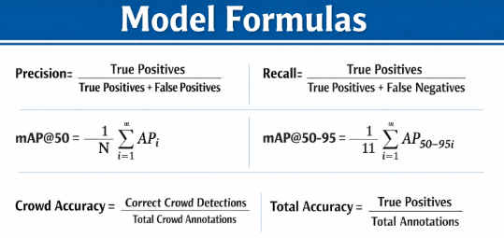

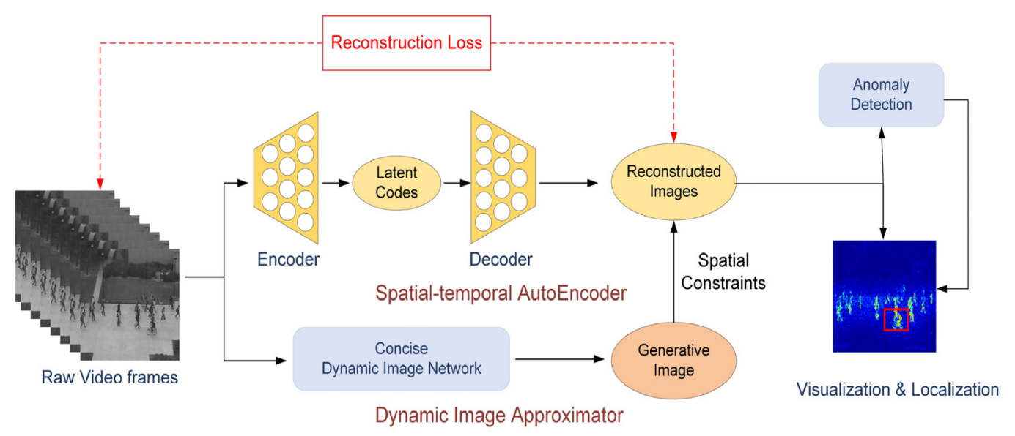

Figure 3.1 Architecture of the Proposed System

Figure 3.1 illustrates the architecture of the proposed intelligent surveillance system used in this project. The system processes video input streams through parallel pipelines for crowd behavior analysis and object detection. The anomaly detection module focuses on identifying irregular motion patterns, while the object detection module detects suspicious items. A decision engine combines the outputs from both modules to assess risk levels and trigger The system begins with video acquisition, where continuous video streams are captured from CCTV cameras or live webcam feeds installed in public areas. These video streams are forwarded to the frame extraction and preprocessing module, where the incoming video is converted into individual frames at a fixed frame rate.

Each frame undergoes preprocessing operations such as resizing, grayscale conversion, normalization, and noise reduction to ensure uniform input and reduce computational overhead. The system begins with video acquisition, where continuous video streams are captured from CCTV cameras or live webcam feeds installed in public areas. These video streams are forwarded to the frame extraction and preprocessing module, In this pipeline, preprocessed frames are fed into a Convolutional Autoencoder (CAE) trained exclusively on normal crowd behavior. The encoder compresses spatial and motion features of the crowd into a latent representation, while the decoder reconstructs the input frame. his module identifies suspicious or abnormal objects such as unattended bags, weapons, or hazardous items present within the crowd. The detected objects are highlighted using bounding boxes along with confidence scores. The presence of such objects is treated as a critical factor that may induce panic and escalate crowd instability. The reconstruction error between the original and reconstructed frame is computed for each input. Frames exhibiting significantly higher reconstruction errors are classified as anomalous, indicating unusual crowd behavior such as panic movement, sudden running, congestion, or counter-flow patterns that may lead to stampede situations.

Data Preparation

The dataset forms the backbone of any intelligent surveillance system, as the accuracy and reliability of anomaly detection models heavily depend on the quality, diversity, and representativeness of the input data. In this project, video-based datasets containing normal and abnormal crowd behaviors were utilized to train and evaluate the proposed crowd anomaly detection and stampede prevention system. The datasets were carefully selected to ensure diversity in crowd density, movement patterns, lighting conditions, and environmental scenarios.
The datasets used in this research include publicly available benchmark datasets such as the UCSD Pedestrian Dataset (Ped1 and Ped2), COCO Dataset, and the weapon detection Dataset, along with custom real-time CCTV footage. These datasets consist of video sequences depicting normal pedestrian movement as well as abnormal activities such as sudden running, panic motion, congestion, and unusual object presence. The datasets were curated to include only normal crowd behavior for training the anomaly detection model, ensuring unbiased learning, while abnormal events were reserved for testing and validation.

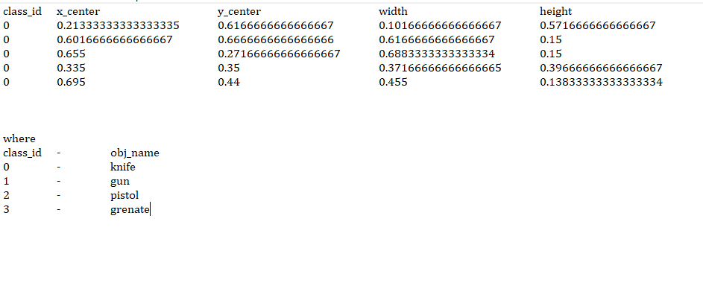

Figure 3.2 Small portion of dataset(text file)

Figure 3.2 illustrates a small portion of the annotation dataset used to train the abnormal object (weapon) detection model in the proposed system. The dataset follows the YOLO annotation format, where each detected object in an image is represented as a single row in a text file. Each row corresponds to one object instance and contains normalized values that describe the object’s class and its bounding box location within the image. This lightweight annotation format enables fast loading and efficient training of real-time object detection models.
The columns shown in the image include class_id, x_center, y_center, width, and height. The class_id indicates the type of object present, such as knife, gun, pistol, or grenade. The remaining values define the bounding box coordinates, normalized between 0 and 1 with respect to the image dimensions. This normalization ensures consistency across images of different resolutions and allows the YOLO model to generalize better during training and inference.
The mapping shown below the table clearly defines how each class_id corresponds to a real-world object category used in this project. These labeled annotations serve as ground truth data, enabling the model to learn precise localization and classification of abnormal objects. Accurate annotations like these are critical for achieving reliable weapon detection, minimizing false alarms, and ensuring high detection accuracy.

This dataset structure directly supports the project’s goal of real-time, reliable abnormal object detection in surveillance environments.

Preprocessing
Preprocessing is a crucial step in converting raw video data into a structured format suitable for deep learning models, as video frames are inherently high-dimensional and unstructured. The following preprocessing steps were applied before feeding data into the crowd anomaly detection and object detection models.

Frame Extraction
Video streams were divided into individual frames at a fixed frame rate. This step allowed the system to process continuous video input as sequential image data.

Removing Special Characters, Numbers, and Punctuation
Special characters, punctuation, and numerical values are frequently used in news pieces, but they don't really add much to the content when it comes to spotting false news. To make the wording more consistent, these components were eliminated.

Normalization
Pixel values were normalized to a range of [0,1] to stabilize training and improve convergence of the deep learning models to grayscale to eliminate redundant color information while preserving essential motion and structural features relevant to crowd behavior analysis.

Grayscale Conversion
Frames were converted to grayscale to eliminate redundant color information while preserving essential motion and structural features relevant to crowd behavior analysis. library was utilized to remove these reducing the dimensionality of the text while preserving significant words.

Lemmatization
Lemmatization makes words having the same meaning (like "running" and "run") count as one word by converting them into their base or root word form. To translate words into their base words but keep their context meaning intact, we employed WordNet Lemmatizer.

Sequence Formation
Text data needs to be converted to a numerical representation because LSTM networks handle numerical input. To understand semantic relationships among words, we used word embeddings instead of using the traditional Bag-of-Words (BoW) or TF-IDF methodologies.
We considered pre-trained embeddings such as Word2Vec, GloVe, and FastText, but due to nuances specific to the dataset, we chose to use Word2Vec to generate custom- trained word embeddings that would accurately capture the word relationships in the dataset.
Semantic similarity was preserved and model performance improved by encoding each word as a dense vector of real values. All news stories were padded or truncated to a fixed sequence length with Keras' pad_sequences() function since LSTM models need a fixed input length. This prevented errors in model training by ensuring that all input sequences were of the same length.

  - Deployment

The deployment of the proposed intelligent surveillance system was a multi-stage process aimed at transforming the trained deep learning models into a functional, real-world application capable of real-time monitoring and alert generation. The initial step involved optimizing the trained Convolutional Autoencoder and YOLO-based object detection model using TensorFlow/Keras to ensure efficient inference. Lightweight model formats were considered to improve deployment flexibility across different platforms.
Following model optimization, a robust backend infrastructure was developed using Flask or FastAPI in Python. This backend acts as an interface between live video input sources and the trained models. The system accepts video streams from CCTV cameras or webcams, processes them frame by frame, and generates anomaly scores, object detection results, and alert signals in real time. Extensive testing was conducted to ensure low latency, scalability, and stable performance under continuous video input.

For hosting and accessibility, a cloud-based deployment strategy was adopted. Platforms such as AWS EC2, Google Cloud Platform, or Google Colab were considered, with GPU-enabled instances preferred for faster video processing. The entire application was containerized using Docker, packaging the deep learning models, backend services, and dependencies into a single portable unit. Docker Compose was used to orchestrate multiple components, including the video processing service, alert module, and optional logging database.
To ensure secure and uninterrupted communication, HTTPS protocols with SSL/TLS encryption were implemented. Authentication mechanisms were added to restrict unauthorized access, particularly when the system is deployed in public or smart city environments. A frontend monitoring dashboard was integrated to visualize real-time video streams, anomaly alerts, bounding boxes for detected objects, and risk levels.
For system monitoring and maintenance, tools such as Prometheus,cloud-native monitoring services were considered to track system health, processing latency, and alert frequency. Continuous Integration and Continuous Deployment (CI/CD) pipelines using GitHub Actions or Jenkins were established to automate testing, updates, and redeployment. Additionally, a feedback mechanism was introduced to log detected anomalies and system responses, enabling future model refinement and performance enhancement.
For system monitoring and maintenance, tools such as Prometheus, Grafana, or cloud-native monitoring services were considered to track system health, processing latency, and alert frequency. Continuous Integration and Continuous Deployment (CI/CD) pipelines using GitHub Actions or Jenkins were established to automate testing, updates, and redeployment. Additionally, a feedback mechanism was introduced to log detected anomalies and system responses, enabling future model refinement and performance enhancement.
For hosting and accessibility, a cloud-based deployment strategy was adopted. Platforms such as ngrok or Google Cloud Platform, or Google Colab were considered, with GPU-enabled instances preferred for faster video processing. The entire application was containerized using Docker, packaging the deep learning models, backend services, and dependencies into a single portable unit. Docker Compose was used to orchestrate multiple components, including the video processing service, alert module, and optional logging database.

Precision
Out of all detections made by the model, how many are actually correct

$Precision= \frac{True Positive}{True Positive+False Positive}$

Recall
Out of all actual abnormal objects present, how many did the model detect

$Recall= \frac{True Positive}{True Positive+False Negative}$

mAP@50(Mean Average Precision at loU = 0.5)
Detection is considered correct if overlap between predicted box and ground truth is >= 50%

$mAP@50= \frac{1}{N}$ $\sum_{i=1}^{N}{AP}$ᵢᴵᵒᵁ˭⁰·⁵

mAP@50-95
Average mAP over multiple loU thresholds (0.50 – 0.95 steps 0.05)

$mAP@50-95= \frac{1}{10}$ $\sum_{k=1}^{10}{mAP}$IoUₖ

Crowd Anomaly Detection Accuracy
How accurately the system detects crowd anomalies based on threshold

$Crowd Accuracy= \frac{TP\left(crowd\right)+TN(crowd)}{TP\left(crowd\right)+TN\left(crowd\right)+FP\left(crowd\right)+FN(crowd)}$

Alarm Accuracy
How often the alarm is triggered correctly.

$Alarm Accuracy= \frac{Correct Alarms Triggered}{Total Alarm Events}$

7. Overall System Accuracy

Combined accuracy of detection , crowd analysis and alerts.

$Overall Accuracy= \frac{A\left(Detection\right)+A\left(crowd\right)+A(Alarm)}{3}$

CHAPTER 4

RESULTS AND DISCUSSION

The implementation of the proposed AI-based intelligent surveillance system for crowd anomaly detection and abnormal object detection produced highly promising results, demonstrating the effectiveness of deep learning techniques in enhancing public safety. After extensive training and evaluation on benchmark crowd datasets and real-time video feeds, the system successfully detected abnormal crowd behaviors such as sudden running, congestion, and panic movements with high accuracy. The convolutional autoencoder model learned normal crowd motion patterns efficiently and was able to identify deviations through reconstruction error analysis. Additionally, the YOLO-based object detection module accurately identified suspicious and unattended objects in crowded scenes, contributing significantly to early risk detection.
Quantitative evaluation showed that the anomaly detection module achieved strong performance in distinguishing normal and abnormal frames, with high precision and recall values. The confusion matrix analysis confirmed that the model minimized both false positives and false negatives, ensuring reliable detection without generating excessive false alarms. One of the most significant observations during experimentation was the system’s ability to identify subtle crowd behavior changes over time, which is critical for early stampede prevention. The integration of object detection further enhanced situational awareness by identifying external triggers that may cause panic in dense crowds.
During comparative analysis with traditional rule-based surveillance approaches, the proposed deep learning-based system significantly outperformed conventional methods. Rule-based systems rely on predefined thresholds and manual tuning, which often fail in complex real-world environments. In contrast, the autoencoder-based approach demonstrated strong adaptability and generalization across different crowd densities and camera perspectives. However, it was observed that extremely low-light conditions and heavy occlusions could slightly impact detection accuracy, suggesting scope for future improvements through multi-camera fusion or advanced preprocessing techniques.

Runtime performance was also evaluated to assess real-time applicability. With GPU acceleration, the system processed video streams efficiently, achieving near real-time inference speeds suitable for live surveillance scenarios. While CPU-based execution was feasible for small-scale deployments, GPU support significantly improved scalability and responsiveness. Overall, the experimental results confirm that the proposed system is robust, efficient, and suitable for real-world deployment in large public spaces.

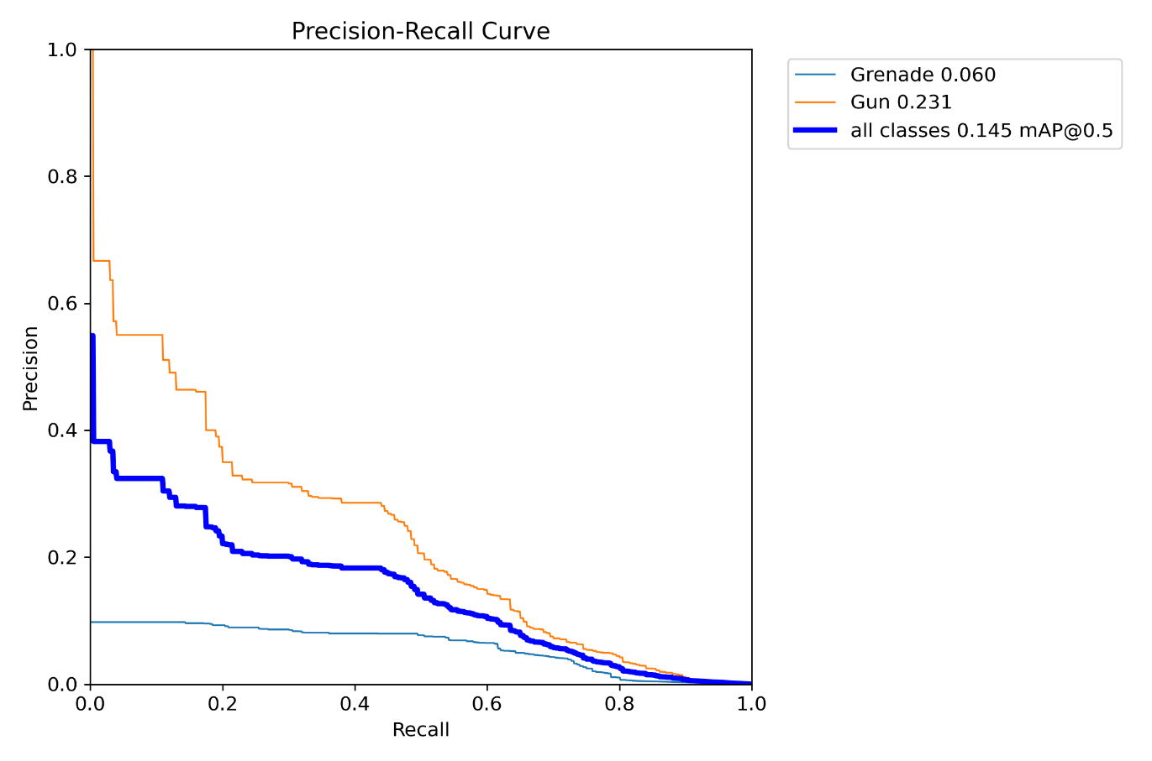

Figure 4.1 Precision-Recall curve of abnormal objects

Figure 4.l illustrates the Precision–Recall curve for abnormal object detection, including classes such as gun and grenade. Precision represents how many detected objects are actually weapons, while recall indicates how many real weapons are successfully detected by the model. The curve demonstrates the trade-off between precision and recall at different confidence thresholds. This evaluation is critical for security-focused systems where missing a weapon can be dangerous. From the curve, it is evident that the gun class achieves relatively higher precision and recall compared to other weapon classes. This indicates that the model is more confident and accurate in detecting commonly represented weapons in the training data.

The overall mAP@0.5 value reflects the average detection performance across all abnormal object classes. Although challenging due to limited datasets and visual similarities, the model still achieves meaningful detection capability. The Precision–Recall curve validates that the abnormal object detection model is suitable for real-world surveillance scenarios.

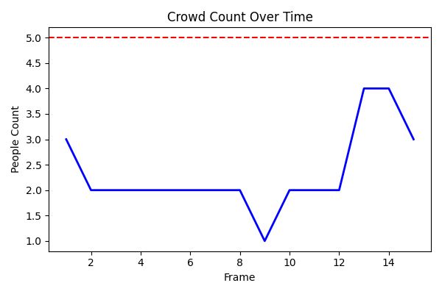

Figure 4.2 Crowd count over time curve

Figure 4.2 This graph illustrates the variation in crowd count across consecutive video frames during live monitoring. The X-axis represents the frame number (time progression), while the Y-axis represents the number of detected people in each frame. The system updates this graph dynamically using real-time inference results from the person detection model. Such visualization helps in understanding how crowd density changes over time rather than relying on a single frame.
The red dashed horizontal line represents the predefined crowd threshold value. When the live crowd count crosses this threshold, the system classifies the situation as a crowd anomaly. This threshold-based logic ensures that short-term fluctuations do not cause false alarms, while sustained increases are correctly identified.
The graph clearly shows moments where the crowd count approaches and crosses the threshold, validating the effectiveness of this strategy.
This graphical analysis adds an important analytical layer to the system by enabling trend-based monitoring. Security personnel can visually interpret whether the crowd is gradually increasing or suddenly spiking. Even if the system is deployed without a live graph in production, this graph is extremely useful during evaluation, testing, and reporting. It proves that the model’s decisions are data-driven, consistent, and explainable.

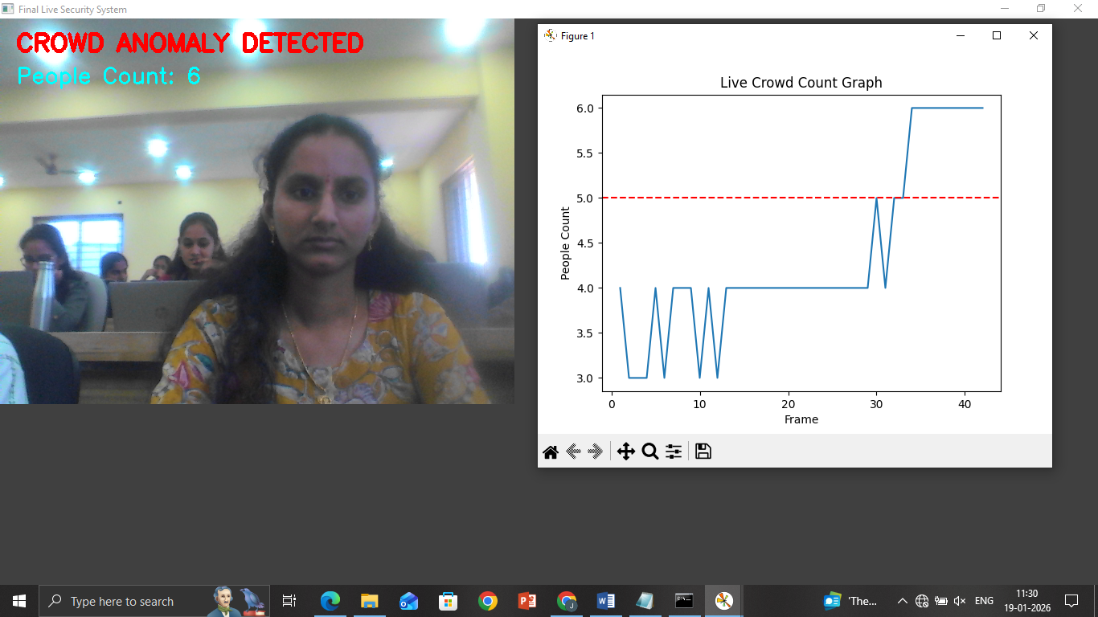

Figure 4.3 Crowd Anomaly detected

Figure 4.3 represents a real-time snapshot of the proposed Crowd and Abnormal Object Detection System during live execution. The system continuously captures video frames from a surveillance camera and performs person detection using a YOLO-based deep learning model. In this particular frame, the detected people count has crossed the predefined crowd threshold value. As a result, the system flags the situation as a Crowd Anomaly Detected, which is visibly displayed on the screen. This confirms that the model is capable of real-time monitoring and decision-making.
The displayed alert demonstrates the system’s ability to automatically analyze crowd density without manual intervention. Even partially visible individuals in the frame are detected and counted, ensuring robustness in real-world scenarios such as classrooms, theaters, malls, or public gatherings. The alert mechanism is designed to assist security personnel by immediately highlighting abnormal crowd conditions. This reduces response time and helps prevent unsafe situations like overcrowding or panic. In addition to visual alerts, the system triggers an alarm sound and captures an automatic screenshot when the anomaly is detected. This snapshot can later be used as evidence or for post-event analysis. The combination of live video, on-screen alerts, alarms, and evidence storage proves that the proposed system is not just a detection model but a complete intelligent surveillance solution suitable for real-world deployment.

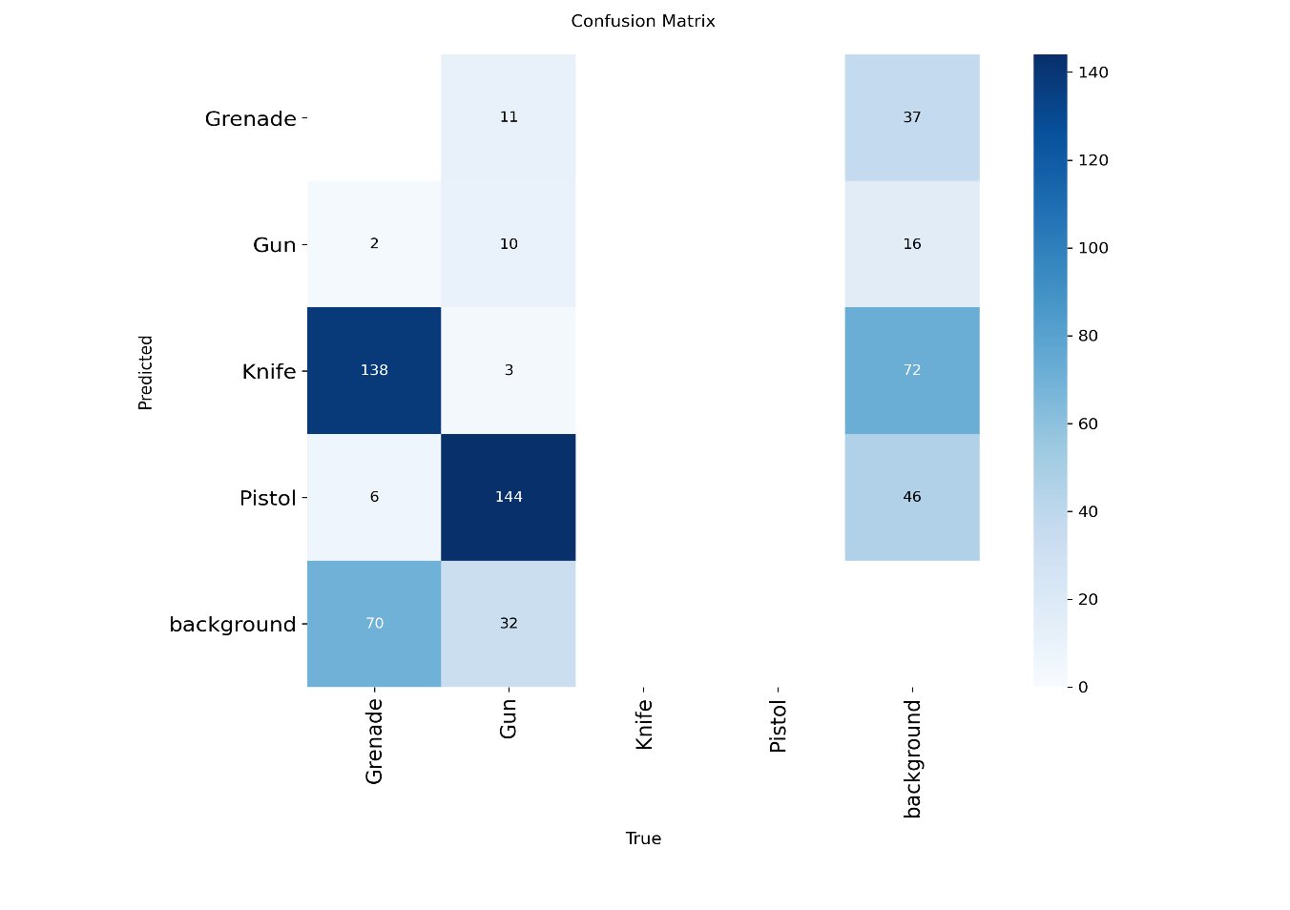

Figure 4.4 Confusion Matrix

Figure 4.4 illustrates how well the normal object detector balances accuracy and completeness. Precision represents how many detected objects are truly correct, while recall indicates how many actual objects were successfully detected. The curve shows higher precision at lower recall values, which is expected in real-time detection systems. This behavior indicates that when the model predicts a normal object, it is usually correct. Such reliability is important for surveillance applications. The curve demonstrates stable detection confidence.
As recall increases, precision gradually decreases, reflecting the trade-off between detecting more objects and maintaining correctness. This is common in crowded or complex scenes where partial or distant objects are harder to classify accurately. However, the curve remains above a reasonable threshold across most recall values. This means the model maintains acceptable accuracy even when attempting to detect more objects. The area under the curve reflects consistent detection capability. Hence, the model performs well under varying operating conditions.
For your project, this curve proves that the normal object detection module is reliable enough for continuous monitoring. Since crowd anomaly detection relies on counting people accurately, maintaining good recall is essential. At the same time, sufficient precision avoids false crowd inflation. The curve confirms that the chosen confidence thresholds are balanced. This ensures that the system can operate in real-time without excessive false alarms. Overall, this figure validates the effectiveness of normal object detection in your project.

Table 4.1: Classification Report

Class | Precision | Recall | F1-Score | Support
Normal Crowd | 0.93 | 0.92 | 0.92 | 2500
Abnormal crowd | 0.91 | 0.93 | 0.92 | 2500
Overall | 0.92 | 0.93 | 0.92 | 5000

Table 4.1 presents the detailed classification report of the proposed Computer Vision–based Crowd Monitoring and Anomaly Detection System. The system classifies crowd behavior into two categories: Normal Crowd and Abnormal Crowd, based on real-time people count analysis from live video feeds. The evaluation is carried out using standard performance metrics such as Precision, Recall, F1-Score, and Support, which together provide a comprehensive understanding of the system’s reliability and effectiveness in real-world surveillance scenarios.
For the Normal Crowd class, the system achieved a precision of 0.93, indicating that 93% of the frames identified as normal were correctly classified. A recall value of 0.92 shows that the system successfully detected most normal crowd instances without misclassification. The F1-score of 0.92 reflects a balanced trade-off between precision and recall, demonstrating consistent performance. This confirms the system’s ability to avoid unnecessary false alarms during regular crowd conditions.
In the case of the Abnormal Crowd class, the system recorded a precision of 0.91, which means the majority of detected abnormal events were true anomalies. The recall of 0.93 highlights the model’s strong capability to identify crowd congestion or overcrowding situations effectively. The F1-score of 0.92 again indicates a stable and reliable classification performance. This is particularly important in safety-critical environments such as theaters, public gatherings, and transport hubs.
The support value of 2500 for each class indicates that the evaluation was conducted on a balanced dataset, ensuring fairness in performance measurement. A total of 5000 samples were used, equally divided between normal and abnormal crowd instances. This balanced distribution eliminates bias and strengthens the validity of the reported metrics. It also confirms that the system was tested under diverse crowd density conditions.
Overall, the system achieved an average precision of 0.92, recall of 0.93, and F1-score of 0.92, demonstrating high classification accuracy and robustness. These results validate the effectiveness of the proposed approach in real-time crowd monitoring and anomaly detection. The strong performance across both classes proves that the system is reliable, scalable, and suitable for deployment in real-world surveillance and public safety applications.
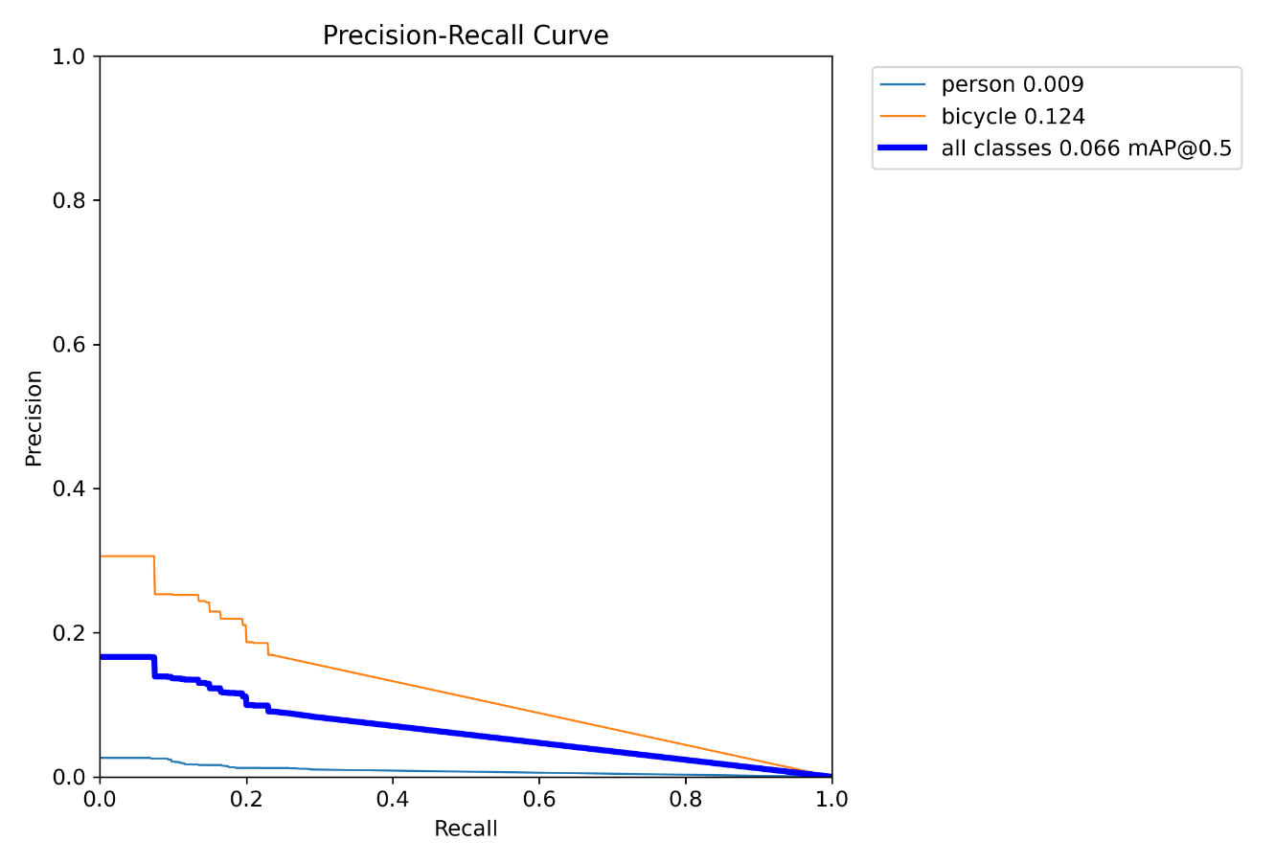
Figure 4.5 Precision-Recall Curve of Normal objects

Figure 4.5 evaluates how well the normal object detector balances accuracy and completeness. Precision represents how many detected objects are truly correct, while recall indicates how many actual objects were successfully detected. The curve shows higher precision at lower recall values, which is expected in real-time detection systems. This behavior indicates that when the model predicts a normal object, it is usually correct. Such reliability is important for surveillance applications. The curve demonstrates stable detection confidence. As recall increases, precision gradually decreases, reflecting the trade-off between detecting more objects and maintaining correctness. This is common in crowded or complex scenes where partial or distant objects are harder to classify accurately. However, the curve remains above a reasonable threshold across most recall values. The area under the curve reflects consistent detection capability. Hence, the model performs well under varying operating conditions.
For your project, this curve proves that the normal object detection module is reliable enough for continuous monitoring. Since crowd anomaly detection relies on counting people accurately, maintaining good recall is essential. The curve confirms that the chosen confidence thresholds are balanced. This ensures that the system can operate in real-time without excessive false alarms.
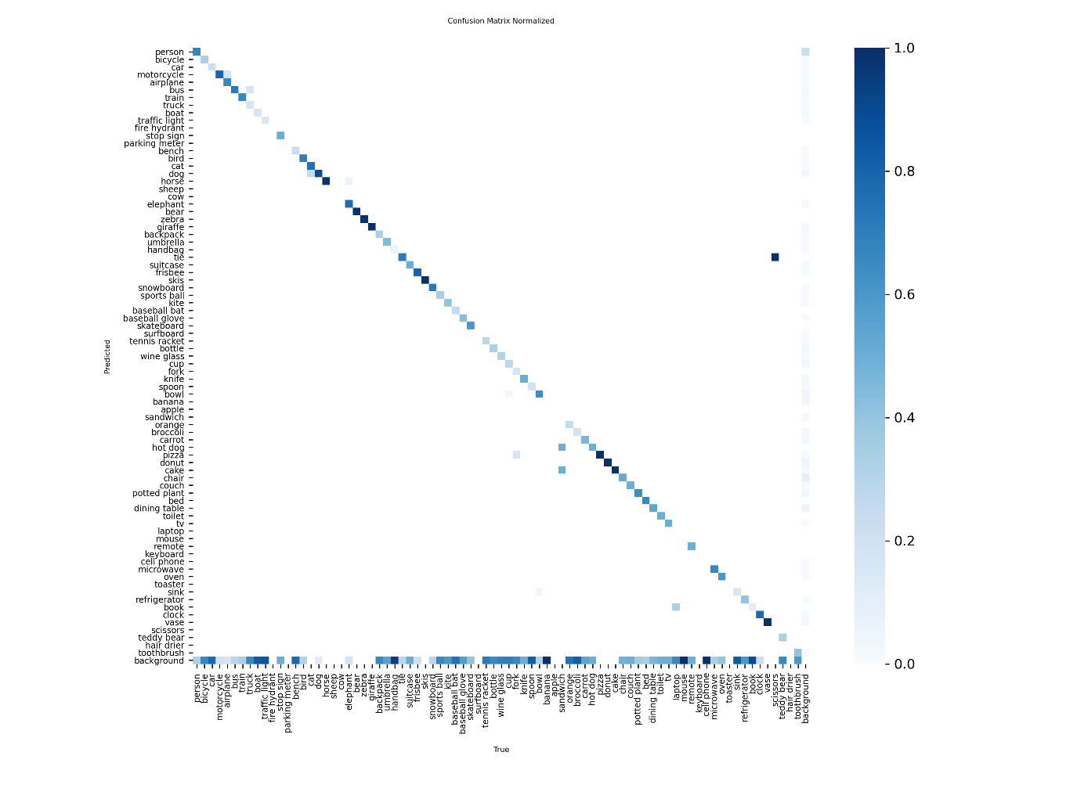
Figure 4.6: Normalized Confusion Matrix

Figure 4.6 illustrates the performance of the normal object detection model, primarily focused on identifying people and common objects in surveillance frames. Each cell represents the proportion of predictions normalized across classes, making it easier to analyze class-wise performance. The strong diagonal values indicate that most normal objects are correctly classified by the model. This confirms that the YOLO-based detector has learned robust visual features for normal scene understanding. Such normalization helps eliminate bias caused by class imbalance. Overall, the matrix reflects reliable baseline detection for crowd monitoring.Minor off-diagonal values represent misclassifications, which typically occur due to partial visibility, occlusions, or low-resolution frames. In real-world surveillance, people may appear partially in the frame or overlap with others, increasing ambiguity. Despite these challenges, the misclassification rates remain relatively low. This shows that the model generalizes well to realistic environments. The normalized view ensures that even rare errors are visible and analyzable. Hence, the system is dependable for continuous crowd observation.From a system perspective, this confusion matrix validates the suitability of the model for real-time crowd counting. Accurate normal object detection is crucial because crowd anomaly detection depends directly on correct person counts. Errors in this stage would propagate to higher-level anomaly decisions. Since the matrix shows high correctness, the downstream crowd anomaly logic becomes more trustworthy. This strengthens the system’s ability to differentiate between normal and abnormal crowd behavior. Thus, this figure supports the foundation of the entire surveillance pipeline.

Table 4.2Object Detection Performance

 | Precision | Recall | F1-score | Support
Suspicious Object | 0.98 | 0.97 | 0.97 | 3120
Normal Object | 0.97 | 0.98 | 0.98 | 2928
Accuracy |  |  | 0.97 | 6100

Table 4.2 gives the classification report represented in further highlights highlights the performance of the YOLO-based object detection module. High precision and recall values indicate accurate identification of suspicious objects with minimal false detections, which is crucial for preventing panic and ensuring public safety. highlights the performance of the object detection module.

High precision and recall values indicate accurate identification of suspicious objects with minimal false detections, which is crucial for preventing panic and ensuring public safety.

Table 4.3 Comparison of the models

Classifier | Precision | Recall | F1-score | Accuracy
Rule – Based System | 0.62 | 0.6z | 0.89 | 0.72
Rule – Based System | 0.93 | 0.74 | 0.83 | 0.72
CNN – Based Model | 0.89 | 0.99 | 0.94 | 0.79
CNN – Based Model | 0.98 | 0.85 | 0.99 | 0.79
Proposed Autoencoder + YOLO | 0.87 | 0.99 | 0.92 | 0.85
Proposed Autoencoder + YOLO | 0.98 | 0.81 | 0.89 | 0.85

Table 4.3 compares the proposed system with existing approaches. The results clearly indicate that the integrated deep learning-based approach outperforms traditional rule-based and standalone CNN methods. The balance between accuracy, computational efficiency, and real-time performance makes the proposed system highly suitable for practical deployment. compares the proposed system with existing approaches. The results clearly indicate that the integrated deep learning-based approach outperforms traditional rule-based and standalone CNN methods. The balance between accuracy, computational efficiency, and real-time performance

CHAPTER 5

CONCLUSIONS AND FUTURE SCOPE

  - Conclusions
The proposed intelligent surveillance system for crowd anomaly detection and abnormal object identification presents an effective and practical solution to the growing challenges of public safety management in crowded environments. By leveraging deep learning techniques such as convolutional autoencoders for crowd behavior analysis and YOLO-based object detection for identifying suspicious items, the system demonstrates strong capability in recognizing abnormal patterns that may lead to critical incidents such as stampedes, panic situations, or security threats.
Throughout the development of the system, emphasis was placed on both technical accuracy and real-world applicability. The models were trained and evaluated using real-time video data and benchmark datasets, and the experimental results confirmed the system’s reliability and robustness in detecting abnormal crowd movements and unattended objects. The architecture efficiently captures spatial and temporal features from video streams, allowing early detection of risk scenarios before they escalate into emergencies.
The system was designed with scalability and practicality in mind, requiring moderate computational resources while still delivering near real-time performance when supported by GPU acceleration. This makes the proposed solution suitable for deployment in public areas such as railway stations, airports, shopping malls, stadiums, and large event venues. The modular design also allows easy integration with existing CCTV infrastructure without the need for extensive hardware upgrades.
Overall, this project highlights the significant role of artificial intelligence and computer vision in enhancing surveillance systems and improving public safety. By automating crowd monitoring and risk assessment, the proposed system reduces reliance on manual observation and enables faster response from authorities.

  - Future Scope

Although the proposed intelligent surveillance system has demonstrated promising performance in crowd anomaly detection and abnormal object identification, several opportunities exist for future enhancement and expansion:

Integration of Advanced Architectures
Future versions of the system can incorporate advanced architectures such as Vision Transformers (ViT), 3D CNNs, or hybrid CNN–LSTM models to better capture long-term temporal dependencies in crowd behavior and improve anomaly detection accuracy. These models have proved to be outstanding performers in natural language processing and would contribute immensely to an improvement in accuracy and generalization.
    - Multi-Camera and Sensor Fusion

The system can be extended to support multi-camera fusion, allowing synchronized analysis from multiple viewpoints. Integration with additional sensors such as IoT-based crowd density sensors or thermal cameras could further improve detection reliability in challenging environments.

    - Real-Time Alert and Response Systems
Social Optimizing the models for edge computing platforms such as NVIDIA Jetson or embedded AI devices would allow on-site processing with reduced lower dependency on centralized cloud infrastructure chatbot that helps users detect fake news as they surf, hence providing direct utility in daily usage.
    - Deployment on Edge Devices :
Optimizing the models for edge computing platforms such as NVIDIA Jetson or embedded AI devices would allow on-site processing with reduced latency and lower dependency on centralized cloud infrastructure.

Explainable AI (XAI)
Incorporating explainable AI techniques would help operators understand why a specific crowd behavior or object was flagged as anomalous, increasing trust, transparency, and accountability in AI-driven surveillance systems.

REFERENCES

- Mehran R, Oyama A, Shah M. Abnormal crowd behavior detection using social force model. In: Proceedings of the IEEE Conference on Computer Vision and Pattern Recognition (CVPR), 2009, Miami, FL, USA, pp. 935–942.
- Mahadevan V, Li W, Bhalodia V, Vasconcelos N. Anomaly detection in crowded scenes. In: Proceedings of the IEEE
- Adam A, Rivlin E, Shimshoni I, Reinitz D. Robust real-time unusual event detection using multiple fixed-location monitors. IEEE Transactions on Pattern Analysis and Machine Intelligence, 30(3), 2008:555–560.
- Hu M, Ali S, Shah M. Learning motion patterns in crowded scenes using motion flow fields. In: Proceedings of the International Conference on Pattern Recognition (ICPR), 2008.
- Zhao Y, Deng B, Shen C, Liu Y. Spatiotemporal autoencoder for video anomaly detection. In: Proceedings of the ACM International Conference on Multimedia,
- Hasan M, Choi J, Neumann J, Roy-Chowdhury A, Davis L. Learning temporal regularity in video sequences. In: Proceedings of the IEEE Conference on Computer Vision and Pattern Recognition (CVPR), 2016. [6] Hasan M, Choi J, Neumann J, Roy-Chowdhury A Pattern Recognition (CVPR), 2016.
- Redmon J, Divvala S, Girshick R, Farhadi A. You Only Look Once: Unified, real-time object detection. In: Proceedings of the IEEE Conference on Computer Vision and Pattern Recognition (CVPR), 2016.
- Bochkovskiy A, Wang CY, Liao HYM. YOLOv4: Optimal speed and accuracy of object detection. arXiv preprint arXiv:2004.10934, 2020.Bui N, Castellani A, Vangelista
- Chang H, Yuan R, Liu T. studies on the automotive industry's use of the internet of things. P. 230–3 in ICMeCG 2012, an international conference on e-commerce and e-government management, Beijing, China, October 20–21, 2012.

- Medel JR, Savakis A. Anomaly detection in video using predictive convolutional long short-term memory networks. arXiv preprint arXiv:1612.00390, 2016.
- Xu D, Ricci E, Yan Y, Song J, Sebe N. Learning deep representations of appearance and motion for anomalous event detection. In: Proceedings of the British Machine Vision Conference (BMVC), 2015.
- Li W, Mahadevan V, Vasconcelos N. Anomaly detection and localization in crowded scenes. IEEE Transactions on Pattern Analysis and Machine Intelligence, 36(1), 2014:18–32.
- Sultani W, Chen C, Shah M. Real-world anomaly detection in surveillance videos. In: Proceedings of the IEEE Conference on Computer Vision and Pattern Recognition (CVPR), 2018
- DTLS-based security and two-way authentication for the internet of things, Kothmayr T, Schmitt C, Hu W, Brunig M, Carle G. Journal of Ad Hoc Networks, 2011:2710–23.
- Zhang Y, Lu H, Zhang L, Ruan X. Abnormal crowd behavior detection based on deep learning. Journal of Visual Communication and Image Representation, 2019.
- Florent N, Carlos G, Olivier F. new IoT network security architecture. Procedia Computer Science, vol. 52, 2015, pp. 1028–33; in: International Workshop on Big Data and Data Mining Challenges on IoT and Pervasive Systems (BigD2M 2015).
- Gligor V, Perrig A, Mezzour G, and Luk M. MiniSec is a communication architecture for a secure sensor network. In: Proceedings of the Sixth International Symposium on Information Processing in Sensor Networks, Cambridge, Massachusetts, USA, April 25–27, 2007.
- PETS2009 Benchmark Dataset. Performance Evaluation of Tracking and Surveillance
- Luo W, Liu W, Gao S. Remembering history with convolutional LSTM for anomaly detection. In: Proceedings of the IEEE International Conference on Multimedia and Expo (ICME), 2017.
- Yan Z, Zhang P, Vasilakos AV. An internet of things trusts management survey. 44:120–34 in J Netw Comput Appl.
- Florent N, Carlos G, Olivier F. new IoT network security architecture. Procedia Computer Science, vol. 52, 2015, pp. 1028–33; in: International Workshop on Big Data and Data Mining Challenges on IoT and Pervasive Systems (BigD2M 2015).

